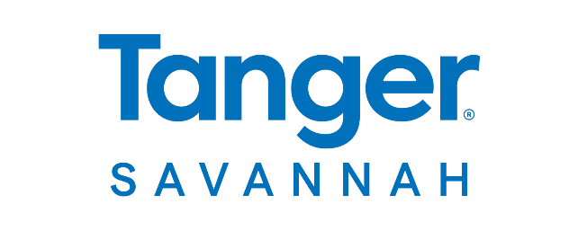

**FOR MORE INFORMATION:**

Caroline Day

BRAVE Public Relations  
404.233.3993

[cday@emailbrave.com](mailto:cday@emailbrave.com)

**\*MEDIA ADVISORY\***

**Tanger Outlets Savannah Invites Community to Celebrate Wellness Day, Sept. 22**

*Annual event to feature health and wellness activities, free screenings and family-friendly fun*

**POOLER, Ga. (Sept. 12, 2024)** – **Tanger Outlets Savannah** welcomes the community to its annual **Wellness Day** on **Sunday, Sept. 22, from 1 – 4 p.m**. This event will feature a variety of activities focused on promoting healthy living, including health and wellness demonstrations, free screenings and exciting giveaways. Families can enjoy food trucks, an obstacle course, glitter tattoos, a rock-climbing wall and our splash pad.

**WHAT: Tanger Savannah Wellness Day**

*Event features health demonstrations, free screenings and fun activities for the whole family*

**WHEN: Sunday, Sept. 22**

1 – 4 p.m.

**WHERE: Tanger Savannah**

200 Tanger Outlets Blvd

Pooler, GA 31322

**HOW:** This event is **FREE** and open to the public.

Connect with Tanger Savannah on [Facebook](https://www.facebook.com/TangerOutletsSavannah/)and [Instagram](https://www.instagram.com/tangeroutletssavannah/?hl=en). For more information, visit [tanger.com/Savannah](https://www.tanger.com/savannah).

# # #